AUGUST 2014 SUMMER SCHOOL PROJECT
It was a pleasure to travel to Belarus with Ellie again this year and, whilst she concentrated her efforts on the general work of the charity, I was able to devote my time to working with our local long-term contact Sergey and his daughter Lera to deliver another five-day Summer School project.
In an exciting new development, Sergey has returned to the teaching profession and on 1 September started work in the English department of School Number 5 in Rogachev. This school is much larger than the Gymnasia, his previous school, with 1074 pupils and 103 teachers, of whom 13 teach the English language but, because the building is not large enough to accommodate all the students, they have to be taught in two shifts. Sergey has been allocated teaching sessions at the beginning and end of the school day, so it’s fortunate that his flat is within easy walking distance!

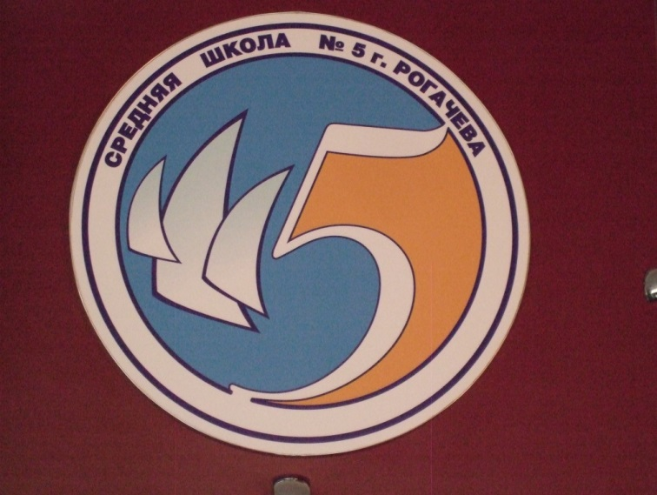
The logo of School No 5 in Rogachev was designed by a family whose children attend the school

On the first morning at the school I met the Headteacher, Natasha, who made me feel extremely welcome but apologised for having to attend meetings throughout the week. Despite being very busy, Natasha was keen to show me around and justifiably proud of the students and the school, despite the ongoing problems of maintaining and improving a large 27-year-old building. I later learned that Natasha’s meetings had involved making a series of presentations to try to obtain some extra funding, so was delighted to hear that School No 5 had been given one of only four awards allocated to the region.

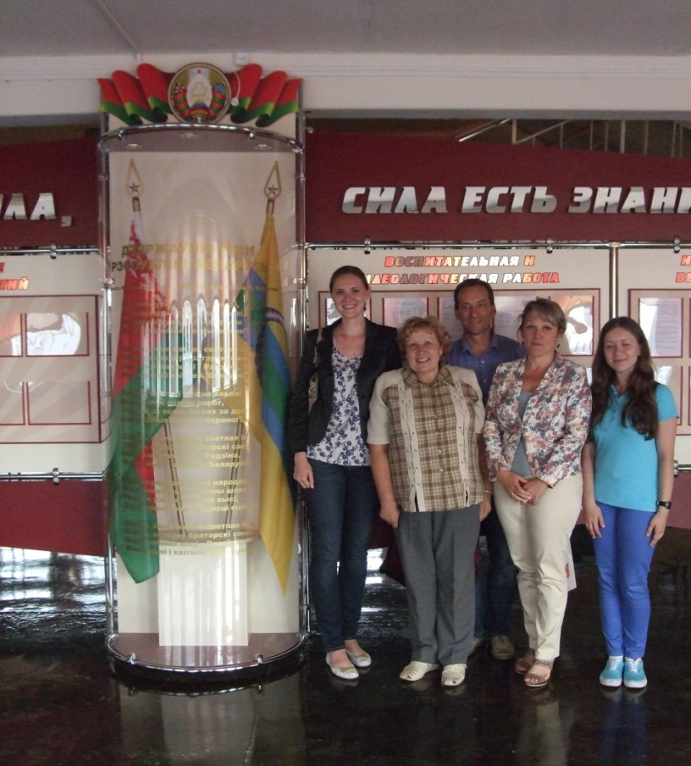
The entrance hall of School No 5
From left to right:
English teachers Natasha, Tania and Sergey, Headteacher Natasha and Lera, Sergey’s daughter, who also helped with classes at this year’s Summer School.

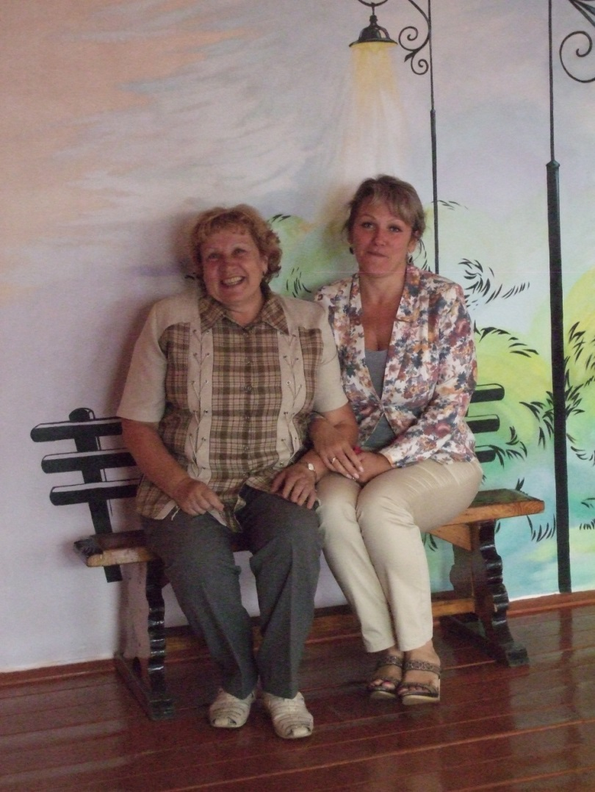
English teacher Tania and Headteacher Natasha in the beautifully decorated sports hall of School No 5

Summer School Project
Following the success of previous Summer Schools, I had intended to repeat the tried and tested formula of five days of classes with three students per hour-long session but, in order to accommodate some students’ prior commitments, this year I sometimes had classes of four students. Seventeen students attended regularly and I was surprised to find a more even mix than in previous years - seven boys and ten girls with ages ranging between 10 and 16 years.
As Sergey had not started work at the school when I visited, he was not familiar with the abilities of the students. The first couple of days were therefore enlightening as I encouraged them to chat, found common ground and we talked about interests and ambitions. They loved playing games I’d devised, asked to play ‘Whot’ (shapes) or ‘Uno’ (colours and numbers) games every day and were well-motivated to complete the homework tasks.
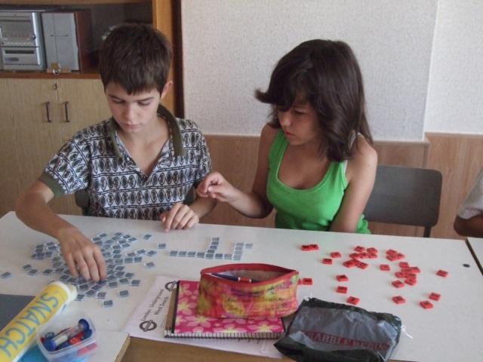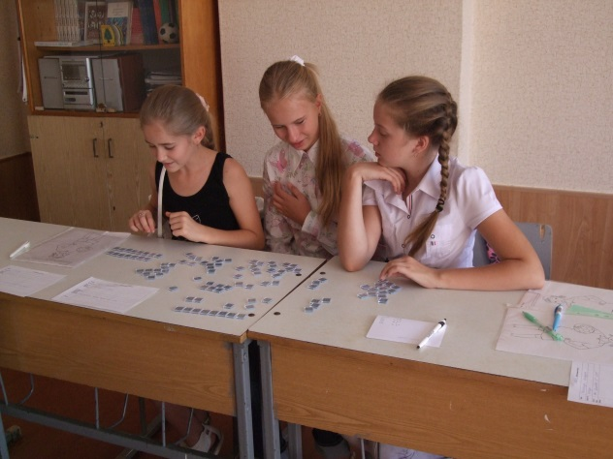

Word games are usually very popular in my classes, but this year a Scrabble Rebus game was also enjoyed by a number of the students

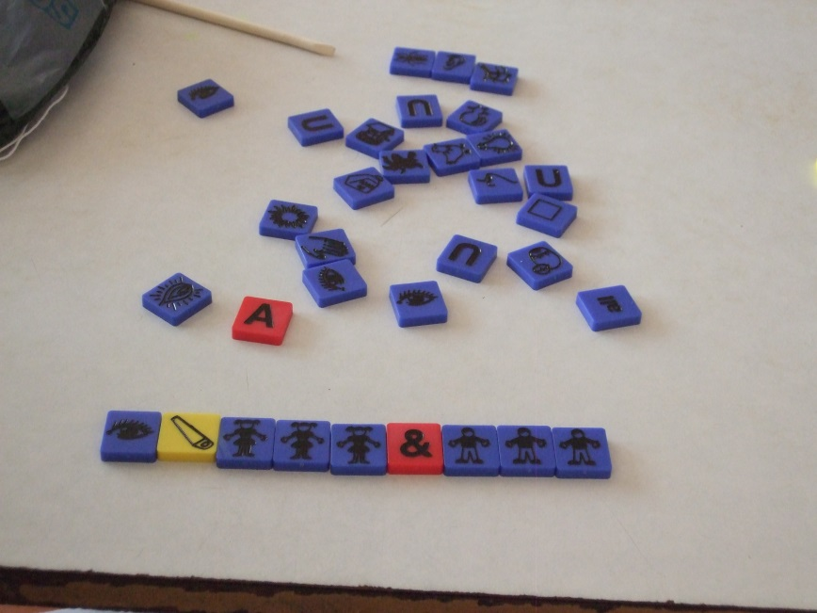

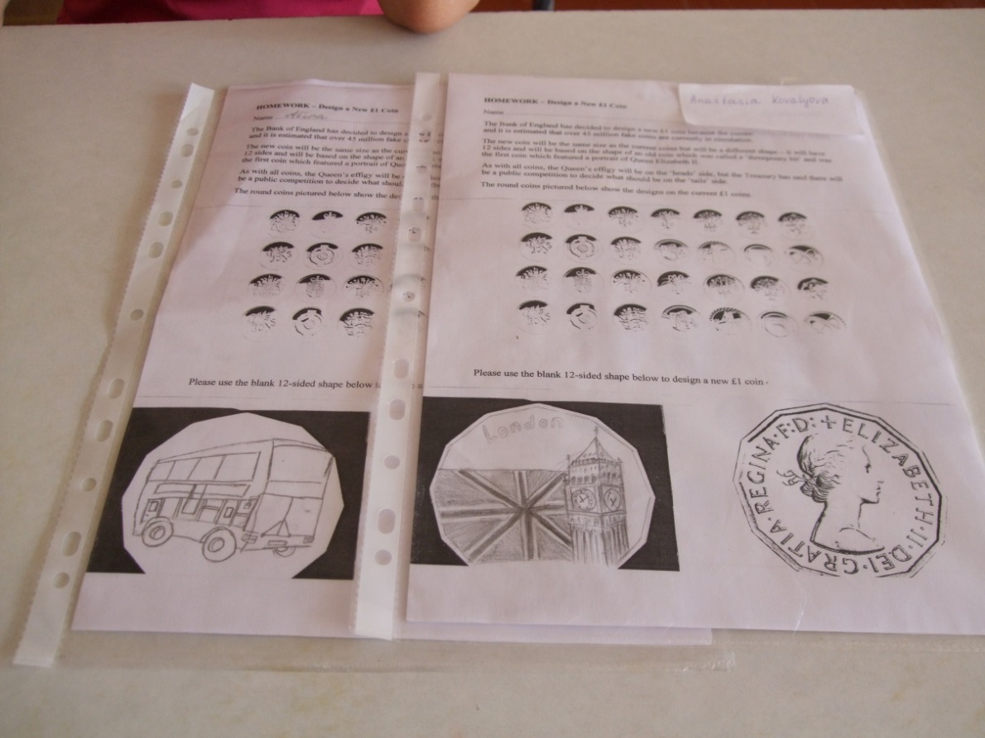
Homework was always tackled with great enthusiasm.
One assignment to draw a design for the proposed new 12-sided UK £1 coin produced some impressive results, as did the one involving London scratch art shapes which were originally completely black.
Sometimes students couldn’t resist starting their homework early – especially if it involved doing a wordsearch!

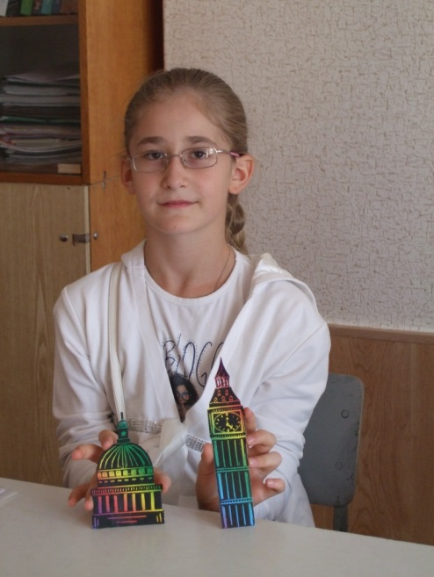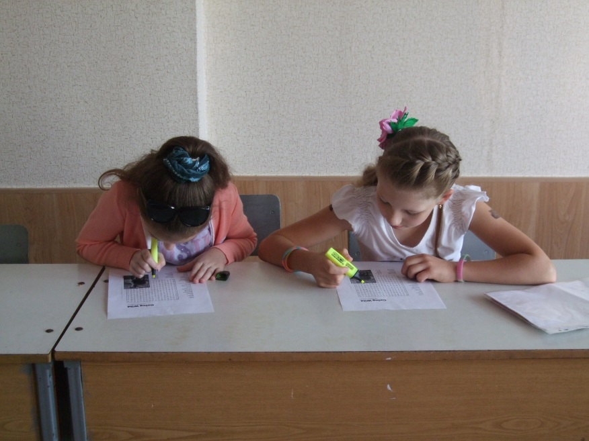

I had prepared a number of new resources but, as these students were all new to my classes, I found myself relying on things I’d used successfully in previous years. However, the afternoon sessions with the older students amazed me as I could have been chatting with native English speakers!
In view of the above, I realised I could quickly work through my supply of suitable resources, but fortunately the older students were also keen to learn about my home town of Weymouth and improve their knowledge of London and our royal family. On Monday and Tuesday we also enjoyed discussing how they learned the English language and what they found funny, strange and/or interesting about the country and the language. I was able to share my problems about learning the Russian language – and caused great hilarity when I told them about the mistakes I’d made with similar-sounding words! We discussed news from both England and Belarus and brainstormed a number of subjects depending on where our conversations led. These sessions were very relaxed and informal and it was extremely interesting to find out about the students, their lives and ambitions without the normal constraints of limited vocabulary and needing to refer to my dictionary - guaranteed to interrupt the flow of any conversation!

The older students became very proficient in delivering tongue-twisters and repetitions at speed – appreciating the ridiculous rhymes or subtle differences between the words - enjoyed adding to my list of new English words in common usage (usually the same in Russian with a slightly different inflection!) and were very keen to play games at the end of a session. It was lovely to work in such a good humoured and relaxed atmosphere, help such enthusiastic students learn more about England and develop their conversational skills.

On Wednesday I gave a powerpoint presentation about ‘Education in England’ which had been requested by Sergey and his colleagues. The younger students sat in for the first part of this before the school photographer arrived to record the presentation of gifts for the school.

As many of the children helped by Galina’s charity attend this School, she had suggested buying equipment with some of the funds from Bridges to Belarus, so Ellie visited a nearby town to buy three music systems which can play CDs, radio and audio files from a USB or MP3 player as well as a laptop computer with carry case and a new cartridge for the printer I used during my visit.

I paid my annual visit to a local family-run outlet with Sergey to buy 25 reams of printer paper, 100 folders 500 punched pockets and 100 pens – and was delighted to be recognised by the proprietor who gave me a good discount and more pens as an extra gift!

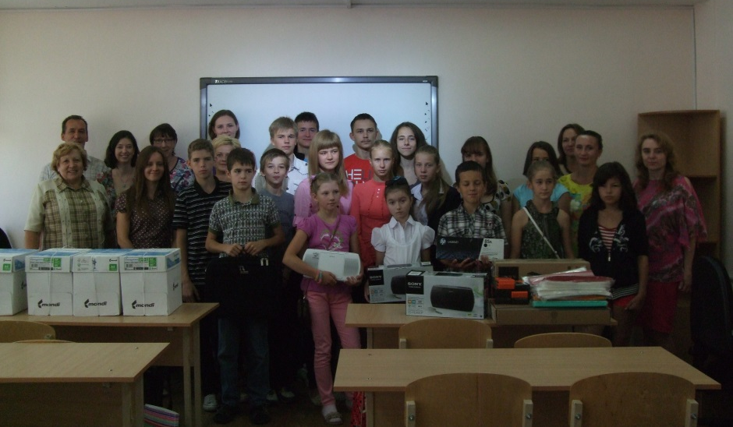
Staff and students of School No 5 with gifts of stationery, music systems and a laptop from Bridges to Belarus
Pictured from the left English teachers Tania and Sergey and B2B representatives Ellie and Sheila at the back

Following the powerpoint presentation, the younger students attended re-scheduled classes, but it was decided that, as the older students were able to attend and understand the whole presentation and then join in and benefit from the discussions afterwards, this should be instead of their daily classes. This then gave me an opportunity to discuss with Sergey and Lera how to plan classes for the remainder of the week and how they could also become involved in these.

On Thursday and Friday afternoon the older students joined as one group with me, Sergey and Lera and we had group discussions – starting with a subject of mutual interest but then naturally following onto many other subjects with everybody encouraged to take part. The second half of the lesson involved games and activities suggested by Lera who has gained considerable experience of organising such things whilst studying languages and interpretation at the university in Minsk. Her input into these sessions to ensure that the more able students enjoyed the week of classes was invaluable and much appreciated.

The last day of the project arrived very quickly and the improved fluency of the younger students was very apparent. I had invited some of the teachers to join the older students’ group and, after another interesting discussion, we played a game organised by Lera. We each had to choose the name of a real person or fictional character and tell the group why he or she should retain a place in a hot air balloon which was rapidly losing height so needed one person to be thrown overboard! Some very interesting discussions arose, but my place in the balloon was never questioned when I told the group that my name was Elizabeth, Queen of England!!

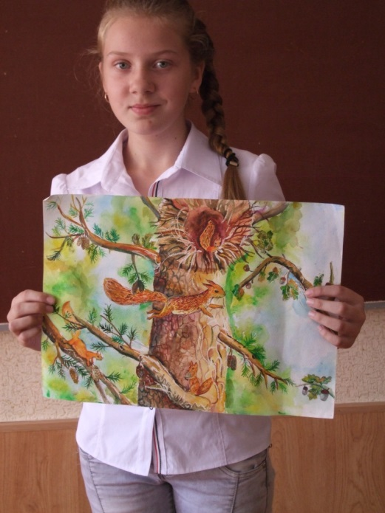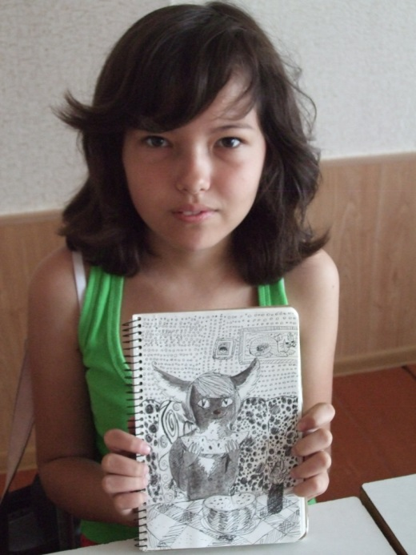

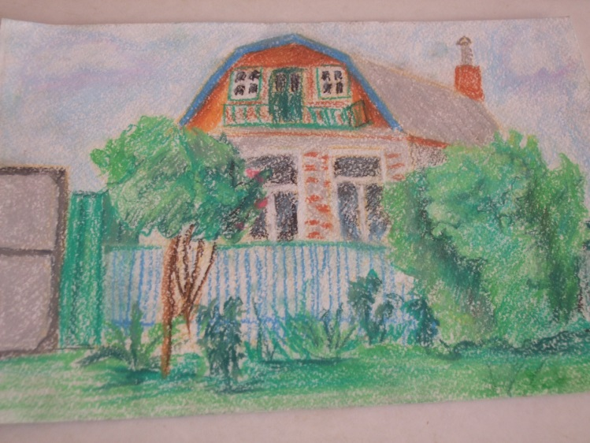
I hadn’t included ‘show and tell’ sessions in my classes, but the pupils were very keen to show me their artwork and other things they’d made

Plans for the Future
I was delighted to receive an invitation from Natasha to return to Belarus and work in School No 5 in August 2015, and have already started to make plans.

- I intend to keep in regular contact with Sergey throughout the academic year and will email interesting information and provide other information as requested by him and his colleagues. It will be a great pleasure to try to help these hard-working teachers.
- I intend to Skype regularly if it is possible to set up a convenient time for a session with the students and teachers in Rogachev.
- Next year, as there are so many students at School No 5, I would like to offer to spend longer in Rogachev and provide two four-day sessions of Summer School classes with one day in between when I can set up another power-point presentation and/or general discussion with the teaching staff.
- I intend to work closely with Sergey and Lera to ensure that all the students have the best possible opportunity to make good progress during their time in the Summer School and hope to be able to link more of the topics studied to those in the Belarusian curriculum.
- I would like to have 3 students of a similar age/ability in my morning classes and feel able to offer four one-hour sessions starting at 0900 and finishing at 1300.
- If Sergey and/or Lera can help, I would like the two one-hour afternoon sessions each day to be for groups of up to six older and/or more able students in an informal environment as these sessions were enjoyed by all the participants this year. However, if some students are less able, then it will be possible to divide into two or three groups for more specific work to ensure that everybody has a positive experience and makes good progress.

Conclusions
Once again, I felt very privileged to have been entrusted to represent B2B and its interests in and around Rogachev. I am looking forward to working with Sergey throughout the academic year, developing good relationships with his colleagues and am very hopeful that it will be possible to develop the Summer School project at School No 5 to help even more students in 2015.

Sheila Furley

